**Assignment 6.1**

**Associated Data Files**

<https://drive.google.com/file/d/0Bxr27gVaXO5sa0JBamZXdkpYUFk/view?usp=sharing>

10-01-1990,123112,10

14-02-1991,283901,11

10-03-1990,381920,15

10-01-1991,302918,22

12-02-1990,384902,9

10-01-1991,123112,11

14-02-1990,283901,12

10-03-1991,381920,16

10-01-1990,302918,23

12-02-1991,384902,10

10-01-1993,123112,11

14-02-1994,283901,12

10-03-1993,381920,16

10-01-1994,302918,23

12-02-1991,384902,10

10-01-1991,123112,11

14-02-1990,283901,12

10-03-1991,381920,16

10-01-1990,302918,23

12-02-1991,384902,10

**Problem Statement:**

Create a database named 'custom'.

Create a table named temperature_data inside custom having below fields:

1. date (mm-dd-yyyy) format

2. zip code

3. temperature

The table will be loaded from comma-delimited file.

Load the dataset.txt (which is ',' delimited) in the table.

Solution:

Create a database named 'custom'

CREATE DATABASE custom;

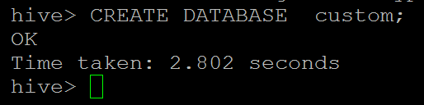

use custom;

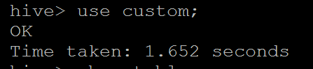

Create a table named temperature_data inside custom having below fields:

1. date (mm-dd-yyyy) format

2. zip code

3. temperature

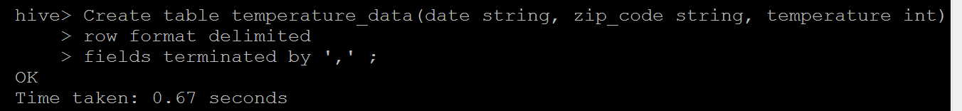

The table will be loaded from comma-delimited file.

Load the dataset.txt (which is ',' delimited) in the table.

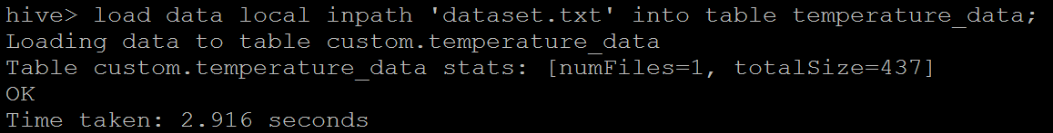

**verification**

